1.6 and 1.7 Quiz (18 points)

Give the Domain and Range for each relation. Then determine if the relation is a function.

1. 2. {(3,4),(4,3),(0,3),(-2,4)}
-1 0 9
3 5 7
3.
X | 5 | 10 | 15 | 20 | 25
Y | -5 | -4 | -3 | -2 | -1

For each function, find f(2), f($\frac{1}{2}$), and $f(-2)$.

4. $f\left(x\right)=-x^{2}+2$ 5. $f\left(x\right)=-5x-6$
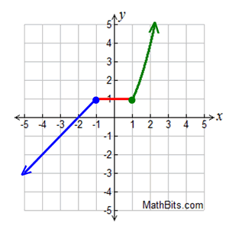
6.

For 7-8, Graph each function.
8. $f\left(x\right)=10-2x$
7. t t 8$2x$
D995

75

65

60

1

3

5

7

r
f

9. The surface area of a cube is 6 times the square of its side length. Write a function to represent the surface are of a cube. What is the value of the function for an input of 10 centimeters, and what does it represent?

